1. Overview
This project implements an end-to-end data pipeline to ingest and process healthcare data from the public HAPI FHIR Server.
The pipeline is built using a Medallion Architecture approach and is orchestrated as a Databricks job named:
FHIR_PIPELINE
The main idea behind the pipeline is to:
- Ingest API data incrementally
- Handle failures without data loss
- Clean and standardize data for analytics
- Maintain historical changes using SCD Type 2
- Track execution using logging
The data flows through multiple layers:
RAW → BRONZE → SILVER → GOLD
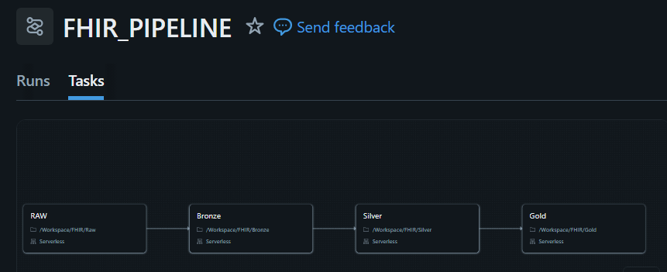
Each layer has a clear responsibility, which helps keep the pipeline scalable and easy to maintain.

2. Pipeline Orchestration
The pipeline is implemented as a Databricks Job (FHIR_PIPELINE) and runs in the following sequence:
- RAW ingestion (API to volume storage)
- BRONZE processing (parsing and structuring)
- SILVER transformation (cleaning and incremental load)
- GOLD processing (aggregation and SCD Type 2)
- Logging at each stage
Each step is modular, so individual layers can be re-run independently if needed.
3. Data Layers
3.1 RAW Layer
The RAW layer is used to store the API response exactly as it is received.
Storage Path:
/Volumes/fhir_catalog/raw/fhir_raw_vol//json/load_date=YYYY-MM-DD/
Key Points:
- Data is stored in JSON format
- Partitioned by load_date
- No transformations are applied
- Acts as a backup layer for reprocessing if needed
This layer ensures that we always have access to the original data.

3.2 BRONZE Layer
The Bronze layer is responsible for converting raw API data into a usable format.
Storage Path:
/Volumes/fhir_catalog/bronze/fhir_bronze_vol//parquet/
Schema:
- id
- resource_data (STRUCT)
- api_url
- extraction_timestamp
- load_date
What happens in Bronze:
- JSON data from RAW is read
- FHIR bundle is parsed
- Each resource is extracted and stored
- Data is stored in a semi-structured format (not fully flattened)
Important Design Choice:
The Bronze layer is intentionally not fully flattened.
Keeping resource_data as a STRUCT allows flexibility for future transformations.
Incremental Logic:
- The system checks available load_date folders in RAW
- Compares with audit logs
- Processes only missing or failed dates
Benefits:
- No hardcoding of dates
- Automatic retry of failed days
- Append-only storage
3.3 SILVER Layer
The Silver layer is where data is cleaned and prepared for analytics.
Storage:
fhir_catalog.silver.
Example (Patient):
- patient_id
- gender
- birth_date
- last_updated
- extract_date
Processing Steps:
- Read data from Bronze
- Extract required fields from resource_data
- Apply:
  - Deduplication based on primary key
  - Null handling
  - Basic data standardization
Incremental Approach:
The Silver layer uses a watermark based on extraction_timestamp.
Only new records are processed:
WHERE extraction_timestamp > last_processed_ts
Why this matters:
- Prevents reprocessing old data
- Improves performance
- Ensures consistency

3.4 GOLD Layer
The Gold layer is used for analytics and reporting.
Table:
fhir_catalog.gold.patient_analytics_scd
Data includes:
- patient details
- total encounters
- total observations
- SCD columns (start_date, end_date, is_current)
Processing Logic:
- Join Patient, Encounter, and Observation data
- Calculate aggregated metrics
- Apply SCD Type 2 logic
SCD Type 2 Behavior:
- When data changes, old record is marked inactive
- New record is inserted with updated values
This allows us to track historical changes over time.
4. Data Relationships
The core relationship revolves around Patient:
Patient → Encounter → Observation
Patient → Condition (optional)
These relationships are used in the Gold layer to build aggregated views.

5. Incremental Processing Strategy
Each layer uses a different approach:
Bronze:
- Detects available partitions from storage
- Processes only missing or failed dates
Silver:
- Uses watermark (extraction_timestamp)
- Processes only new records
Gold:
- Uses Delta MERGE
- Applies SCD Type 2 logic

6. Failure Handling
The pipeline is designed to recover automatically from failures.
- Bronze reprocesses missing load_dates
- Silver does not update watermark on failure
- Gold merges are idempotent and safe to rerun
This ensures no data is lost.

7. Logging
Logging is implemented across all layers:
Tables:
- fhir_catalog.audit.bronze_log
- fhir_catalog.audit.silver_log
- fhir_catalog.audit.gold_log
Each log captures:
- run_id
- resource
- status
- start_time and end_time
- record_count
- message
This helps in monitoring and debugging pipeline runs.
8. Summary
This pipeline demonstrates how to build a scalable and reliable data processing system using Medallion Architecture.
Key highlights:
- Incremental ingestion from API
- Dynamic handling of missing or failed data
- Structured data transformation across layers
- Historical tracking using SCD Type 2
- End-to-end logging for monitoring
Overall, the design focuses on simplicity, reliability, and maintainability while ensuring the data is ready for analytics and reporting.

